Praktikum Pemrograman GUI Pertemuan 3

Daftar Materi

1. Opening Files in Python & Processing File Content

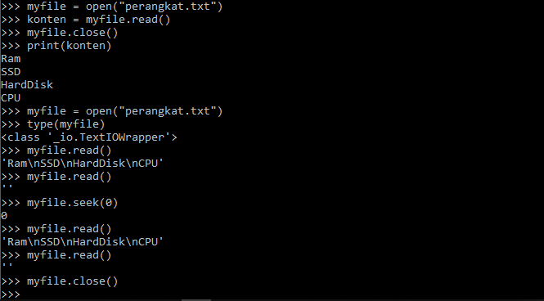

1. For Loop

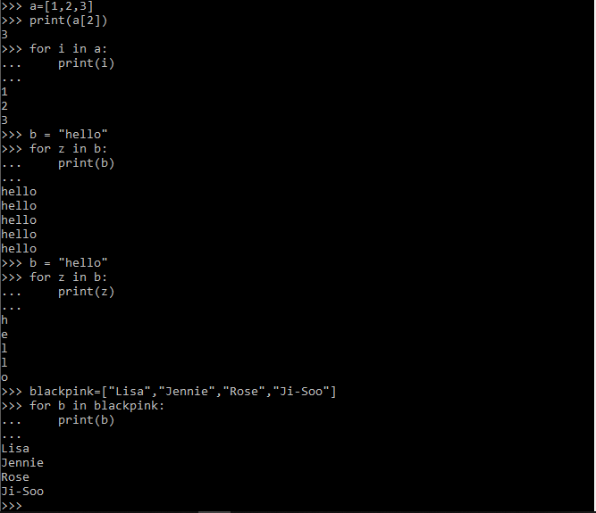

1. Writing Text to File

